85 & Counting Beneficiaries

The American Women’s Club of The Hague has an 85 year history of philanthropy, whereby we have touched and improved lives in our community of The Hague and beyond. The tradition of giving back has been the primary focus of our organization since its inception and continues to this day. Since 2002 alone, our charity galas have donated 1.5 million Euros to our beneficiaries. Our 85 & Counting Anniversary Benefit will support the following organizations:

________________________________________________________________________________________________________________________________

Hulphond Nederland trains therapy dogs to help children with autism, mental handicaps and/or severe behavioural problems learn to function better and communicate more clearly. Children develop emotionally, cognitively, and socially. They also learn to regulate aggression, feel more confident, and develop an improved sense of wellbeing. At the same time, children learn respect for authority figures. Your donation is linked to the training of our AWC sponsored puppy, Yankee, purchased from funds raised from our 2014 Hearts & Minds Gala. hulphond.nl |  |  | 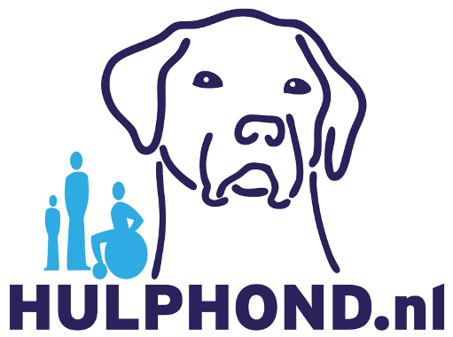
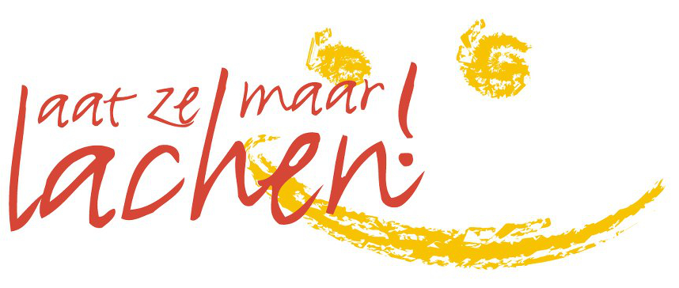 |  | “Let Them Laugh” is dedicated to the most vulnerable children in the Netherlands, those living below the poverty line. Laat ze Maar Lachen treats children between the ages of four and twelve to a day of fun, whether it’s a visit to a zoo or museum, to an amusement park, or to a hands-on crafts show. The organization is run entirely by volunteers and their families and is a registered Dutch ANBI. laatzemaarlachen.com
The Lighthouse Special Education is the only school of its kind in the Netherlands serving members of the international community whose children have special educational needs. Working in English and seeking advice and support from parents and educational institutions, Lighthouse Special Education offers a new chance for children with complex behavioral and/or developmental problems to be part of the community. lighthousese.nl |  |  | 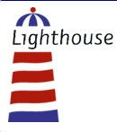
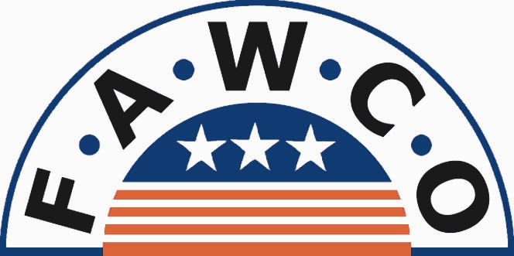  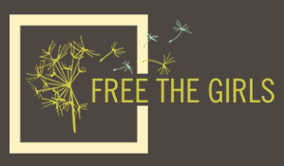 | AWC The Hague is a founding member of The Federation of American Women’s Clubs Overseas (FAWCO), a Non-Governmental Organization (NGO) with special consultative status to the United Nations Economic and Social Council. FAWCO is a network of independent American and international volunteer organizations. In March 2014, FAWCO selected Free The Girls as their Target Project: Human Rights for Women. Free the Girls, a non-profit organization that provides job opportunities for survivors of sex trafficking in Mozambique, Uganda and El Salvador. The group donates gently used bras to rescued women as starting inventory for their own business selling the bras. fawco.org and freethegirls.org

