Instructions for resetting your AWC Member password

1.) You will receive an email with the subject “Choose a new password for your AWC The Hague account”
2.) It may show you a current password. If you like this password, just note it and use it to login on the AWC Website. Otherwise if you want to change it, click on the link in the email to re-set it . The link may look like this link https://awcthehague.wildapricot.org/Sys/ResetPasswordRequest

Example email

Dear Julie Otten,

Here is your login information for AWC The Hague.
Email: juewelsotten@gmail.com
Password: *******
If you would like to reset your password please use this link:https://awcthehague.wildapricot.org/Sys/ResetPasswordRequest

Password requirements

Minimum of 7 characters
Maximum of 50 characters
Any combination of letters, numbers and characters (except spaces)

Log in at www.awcthehague.org with your email and password above to access the member area of our website.

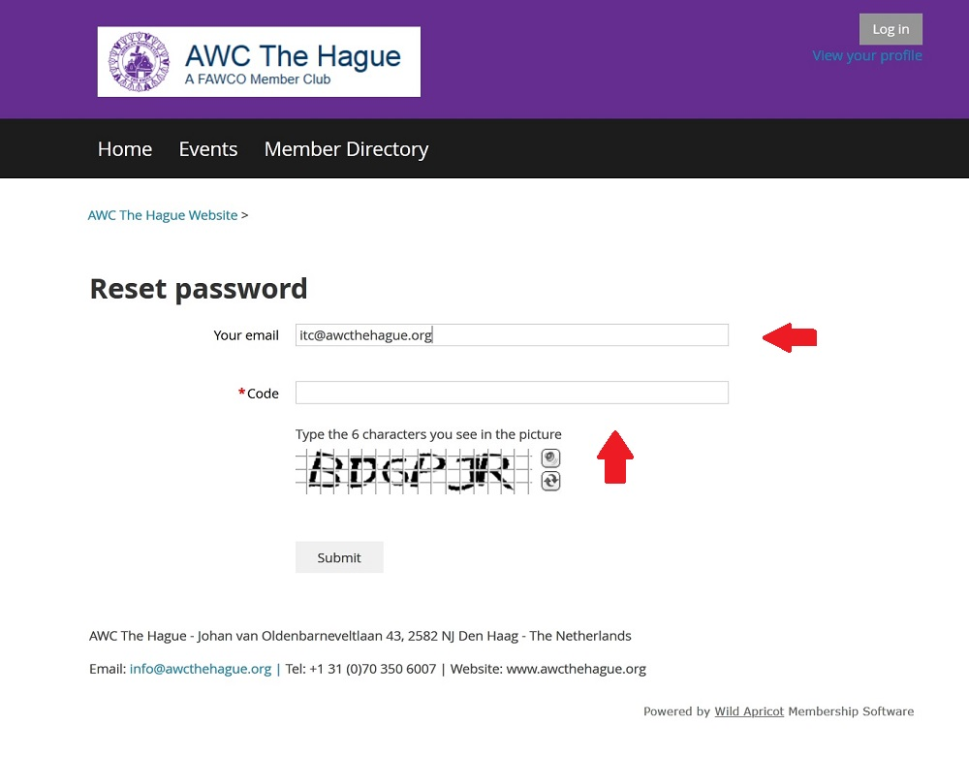

3.) On the page type in your email, if it’s not already filled in.
4.) Type in the 6 digit code you see.
5.) Click the Submit button.

You will get a screen notification telling you an email will be sent to your inbox.

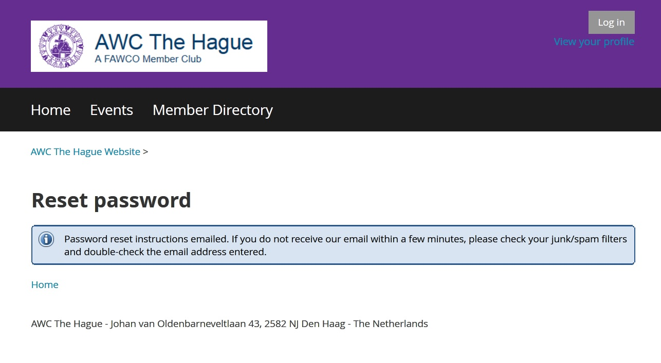

- ) Check your email inbox for an email
From: AWC The Hague
Subject: Choose a new password for your AWC The Hague account
7.) Click on the link in the email.
8.) Type in your new password. And click submit.

You will get an online confirmation that the password has been reset.
Now you can login to your AWC member account on our website using the login button in the upper right or the member login on the top menu navigation.

